Practice EST Name ____________________________
Question 1 (11 marks)
A group of scientists was investigating a synthetic hormone called Meta-booster, which was
designed to increase metabolic rate in people suffering from hypothyroidism. Early tests involved
administrating Meta-booster to mice suffering from the same condition. Six mice were placed in
a small chamber that was linked to an oxygen-measuring device. After five days, the mice were
given a single dose of Meta-booster.
(a) For this investigation, state the
(i) independent variable. (1 mark)

(ii) dependent variable. (1 mark)

(b) State three variables that need to be controlled to make the investigation valid. (3 marks)
One:
Two:
Three:
(c) List two ways to improve the reliability of the investigation. (2 marks)
One:
Two:

The results of the investigation are shown in the graph below.
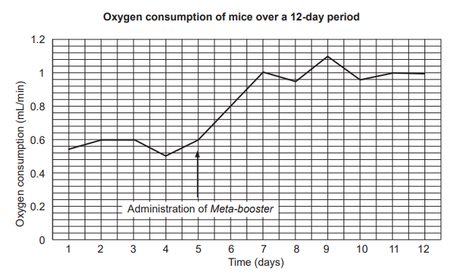
(d) Describe two trends in the oxygen consumption of the mice over the 12-day period, using
data from the graph. (4 marks)
___________________________________________________________________________________________________________________________________________________________________________________________________________________________________________________________________________________________________________________________________________________________________________________________________________________________________________________________________________________________

Question 2 (9 marks)
The combined oral contraceptive uses two hormones which disrupt the natural menstrual cycle and prevent pregnancy.
- list the two hormones (2 marks)
_____________________________
_____________________________
- Explain how pregnancy is prevented by these hormones (3 marks)
______________________________________________________________________________________
______________________________________________________________________________________
______________________________________________________________________________________
- Describe how the levels of these hormones change naturally over the course of the menstrual cycle and explain the effects of each. (4 marks)
________________________________________________________________________________________________________________________________________________________________________________________________________________________________________________________________________________________________________________________________________________________

Question 3 (6 marks)
The Gardasil vaccine is given for free in Australia to girls and boys ages 13-14.
- What virus does the vaccine prevent against? __________________ (1 mark)
- What is the main complication for this virus in women? _______________________ (1 mark)
- Explain why there needs to be three doses at 0, 2 and 6 months (2 marks)
__________________________________________________________________________________________________________________________________________________________________________________________________________________________________________________________________
- Explain why it is given to both boys and girls (2 marks)
________________________________________________________________________________________________________________________________________________________________________________________________________________________________________________________________________________________________________________________________________________________

Question 4 (9 marks)
You want to find out whether the temperature that sperm is frozen at affects the rate of fertilisation in IVF. Your job is to design an experiment which addresses this.
- Write a hypothesis (1 mark)
____________________________________________________________________________________________________________________________________________________________________________
- Write a procedure as to how you are going to conduct the experiment. (8 marks)
_____________________________________________________________________________________________________________________________________________________________________________________________________________________________________________________________________________________________________________________________________________________________________________________________________________________________________________________________________________________________________________________________________________________________________________________________________________________________________________________________________________________________________________________________________________________________________________________________________________________________________________________________________________________________________________________________________________________________________________________________________________________________________________________________________________________________________________________________________________________________________________________________________________________________________________________________________________________________________________________________________

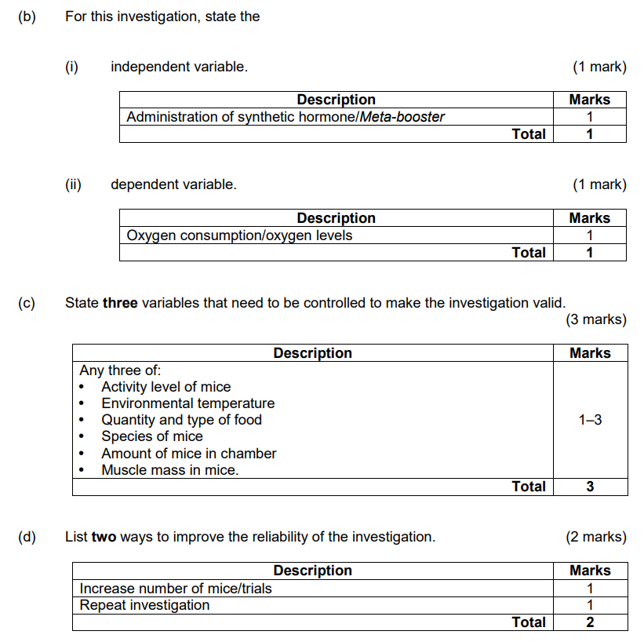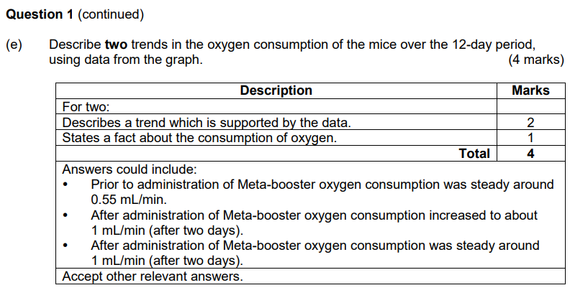
Question 2 (9 marks)
The combined oral contraceptive uses two hormones which disrupt the natural menstrual cycle and prevent pregnancy.
- list the two hormones (2 marks)
estrogen, progesterone
- Explain how pregnancy is prevented by these hormones (3 marks)
Thins lining of uterus so implantation cannot occur, thickens cervical mucus to provide physical barrier for sperm so it cannot fertilise egg, prevents ovulation
(must have explanation)
- Describe how the levels of these hormones change naturally over the course of the menstrual cycle and explain the effects of each. (4 marks)
Estrogen – active in the first half of the cycle (1) to cause uterine lining to build up after a period(1)
Progesterone – active after ovulation(1) to maintain thick lining for implantation(1)

Question 3 (6 marks)
The Gardasil vaccine is given for free in Australia to girls and boys ages 13-14.
- What virus does the vaccine prevent against? HPV_ (1 mark)
- What is the main complication for this virus in women? Cervical cancer (1 mark)
- Explain why there needs to be three doses at 0, 2 and 6 months (2 marks)
Antibodies need to reach a certain level in the body – time between given for body to get used to them and produce own antibodies.
- Explain why it is given to both boys and girls (2 marks)
HPV can cause genital warts/other symptoms (mark only if other is specified) (1)
Herd immunity reduces transmission for everyone (1)

Question 4 (11 marks)
You want to find out whether the temperature that sperm is frozen at affects the rate of fertilisation in IVF. Your job is to design an experiment which addresses this.
- Write a hypothesis (1 mark)
Mark if relates dependent and independent variable – no mark if ‘I think’ or ‘because’
- Write a procedure as if you were writing how you conducted the experiment in a lab report. (10 marks)
Includes safety (1)
Addresses ethics (1)
Has at least three controls (3)
Written in past tense (1)
Correct sequence (1)
Includes multiple trials (1)
Demonstrates knowledge of processes (2)
Any of:
- Stimulate with hormone for egg production
- Egg placed with sperm – not ICSI unless specified
- Screened for motility
Any other acceptable answer

